Name: Santhosh Dinesh R Reg No:192421117

LAB MANUAL

Ethical Hacking Laboratory – Kali Linux Commands and Nmap Scanning

Course Code: Ethical Hacking Laboratory

Software Required: Kali Linux (Latest Version)

Experiment 9

Nmap Timing and Performance Commands

Aim
To perform IDS evasion and timing scans using Nmap.

Theory
Timing options control the speed and stealthiness of Nmap scans.

Commands

i) Polite IDS Evasion
nmap -T2 192.168.1.10

Description:
Slows down scanning to reduce the chance of detection.

ii) Normal Scan
nmap -T3 192.168.1.10

Description:
Default balanced scanning speed.

Procedure
- Identify target IP address.
- Execute Nmap timing commands.
- Observe scan duration and results.
- Compare scan speeds.

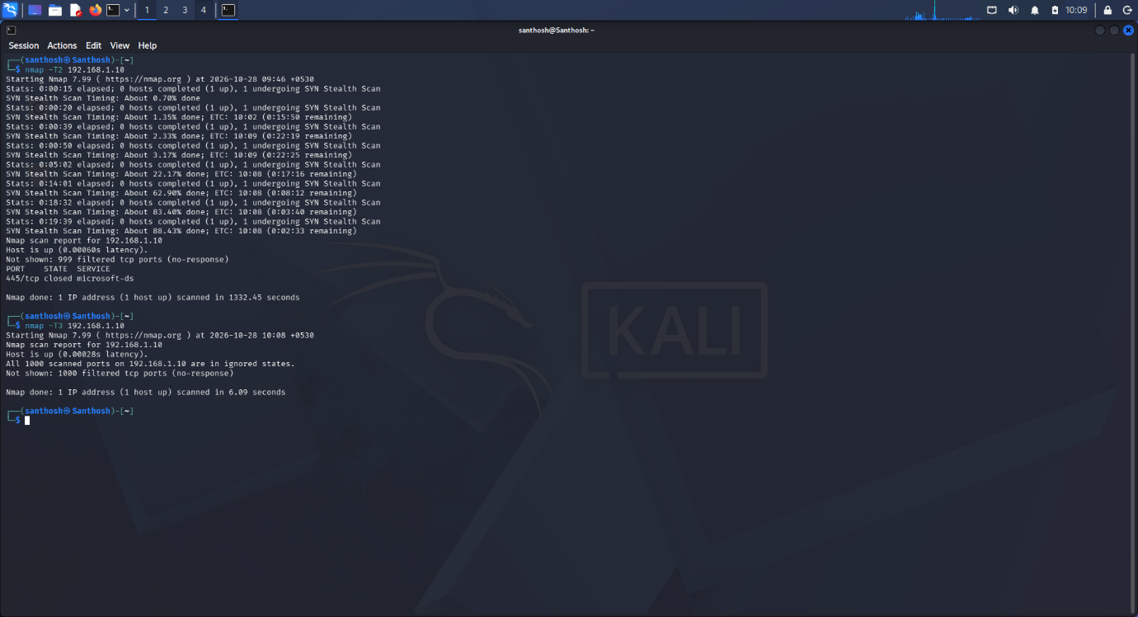

Result
Successfully executed Nmap timing and performance scans in Kali Linux.

